Use case diagram
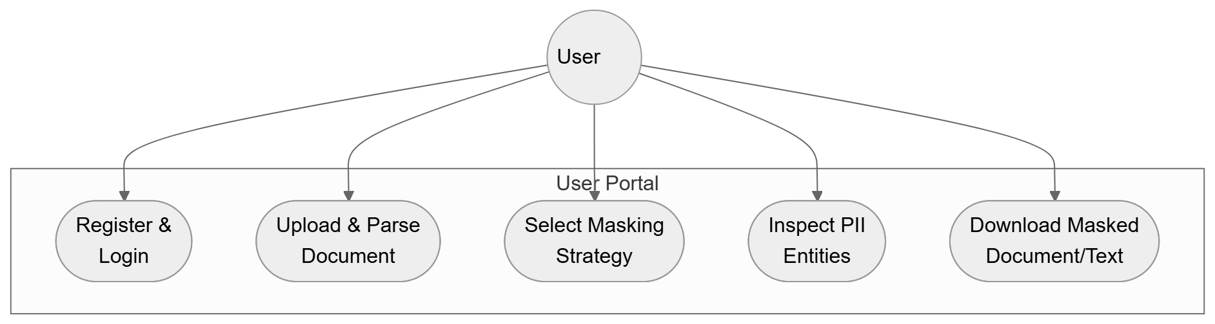
Key Flow:
- Authenticates and accesses the document processing dashboard.
- Uploads financial/sensitive documents and selects desired masking policies.
- Reviews identified entity spans and exports redacted assets.
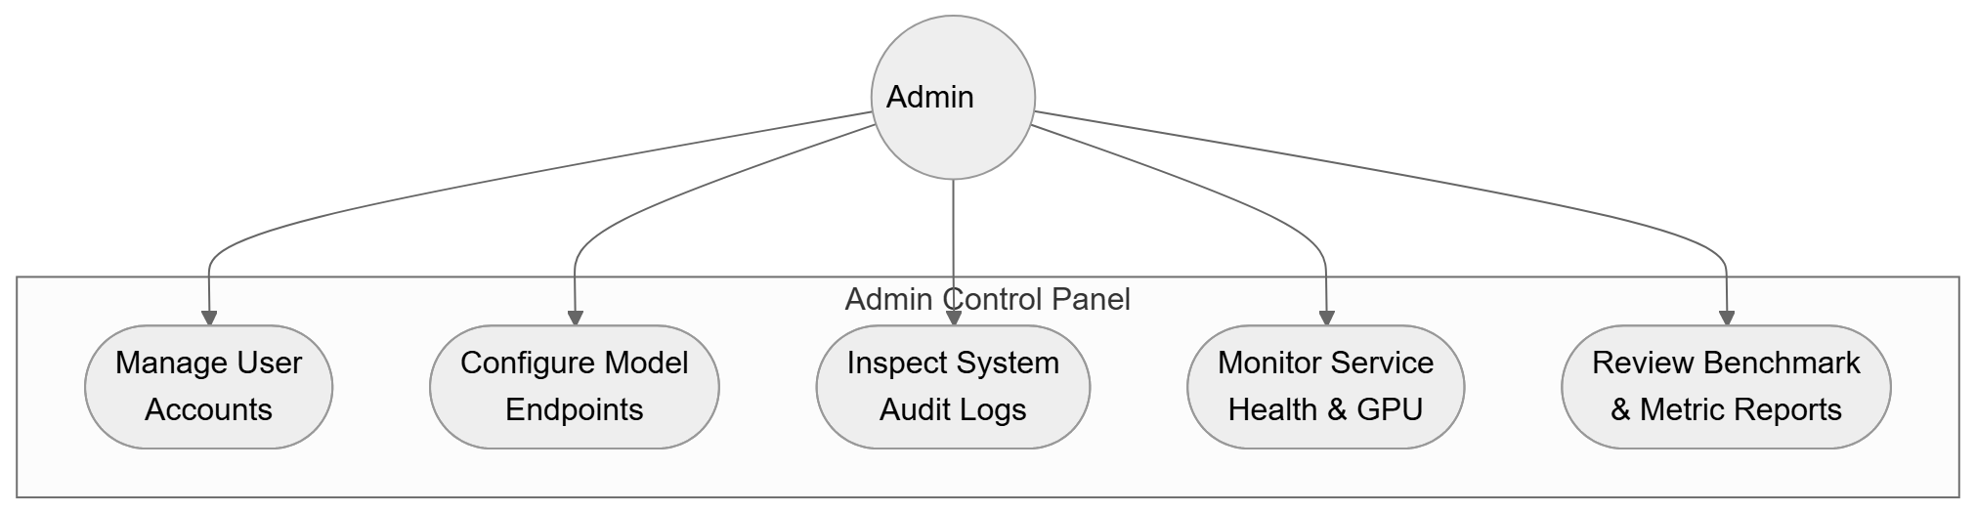
Key Flow:
- Manages user access, security roles, and processing permissions.
- Monitors model service health, GPU resource consumption, and inference latency.
- Reviews evaluation benchmarks and system audit trails.

Class diagram
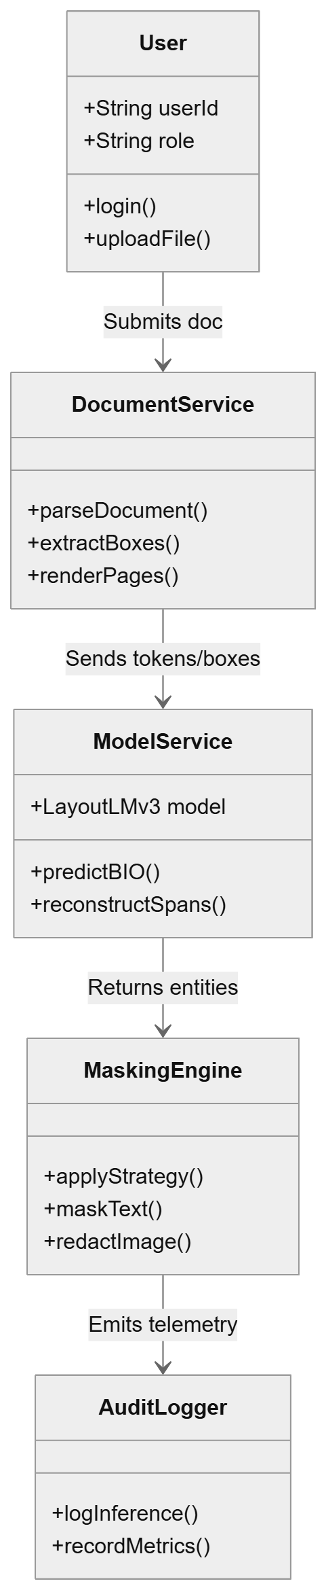
Key Flow:
- User submits raw payloads to DocumentService for extraction and normalization.
- ModelService executes LayoutLMv3 token classification and span assembly.
- MaskingEngine transforms spans into redacted text/images and logs execution metrics.

Activity diagram
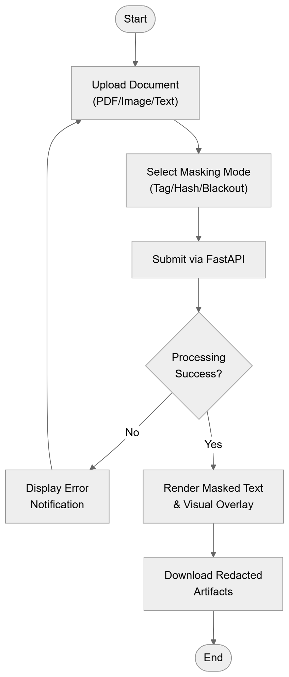
Key Flow:
- User uploads document and selects redaction policy.
- System executes multimodal token classification via API.
- Interface renders live comparison and provides export options.
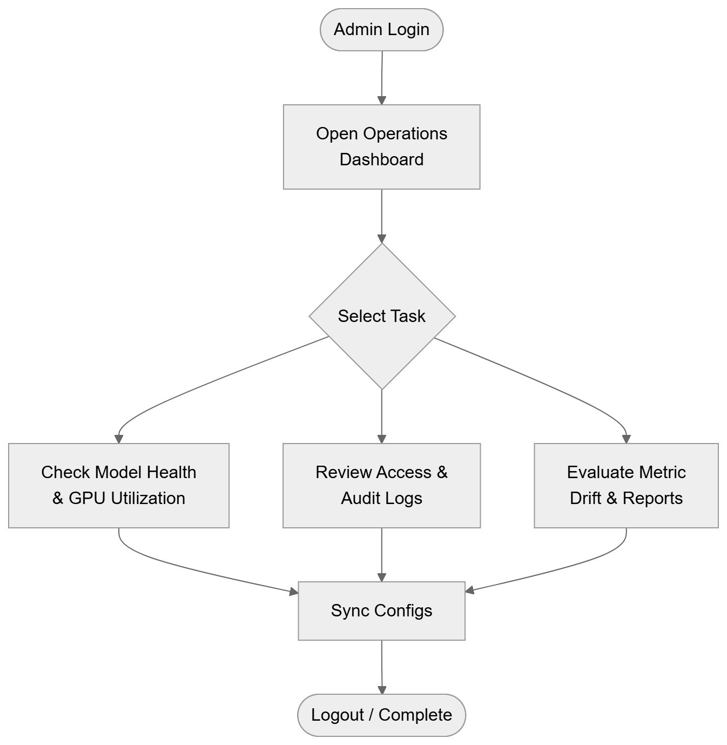
Key Flow:
- Admin authenticates into operations portal.
- Selects operational tasks (infrastructure telemetry, access logs, metric audits).
- Updates system configurations or terminates session.

Sequence diagram
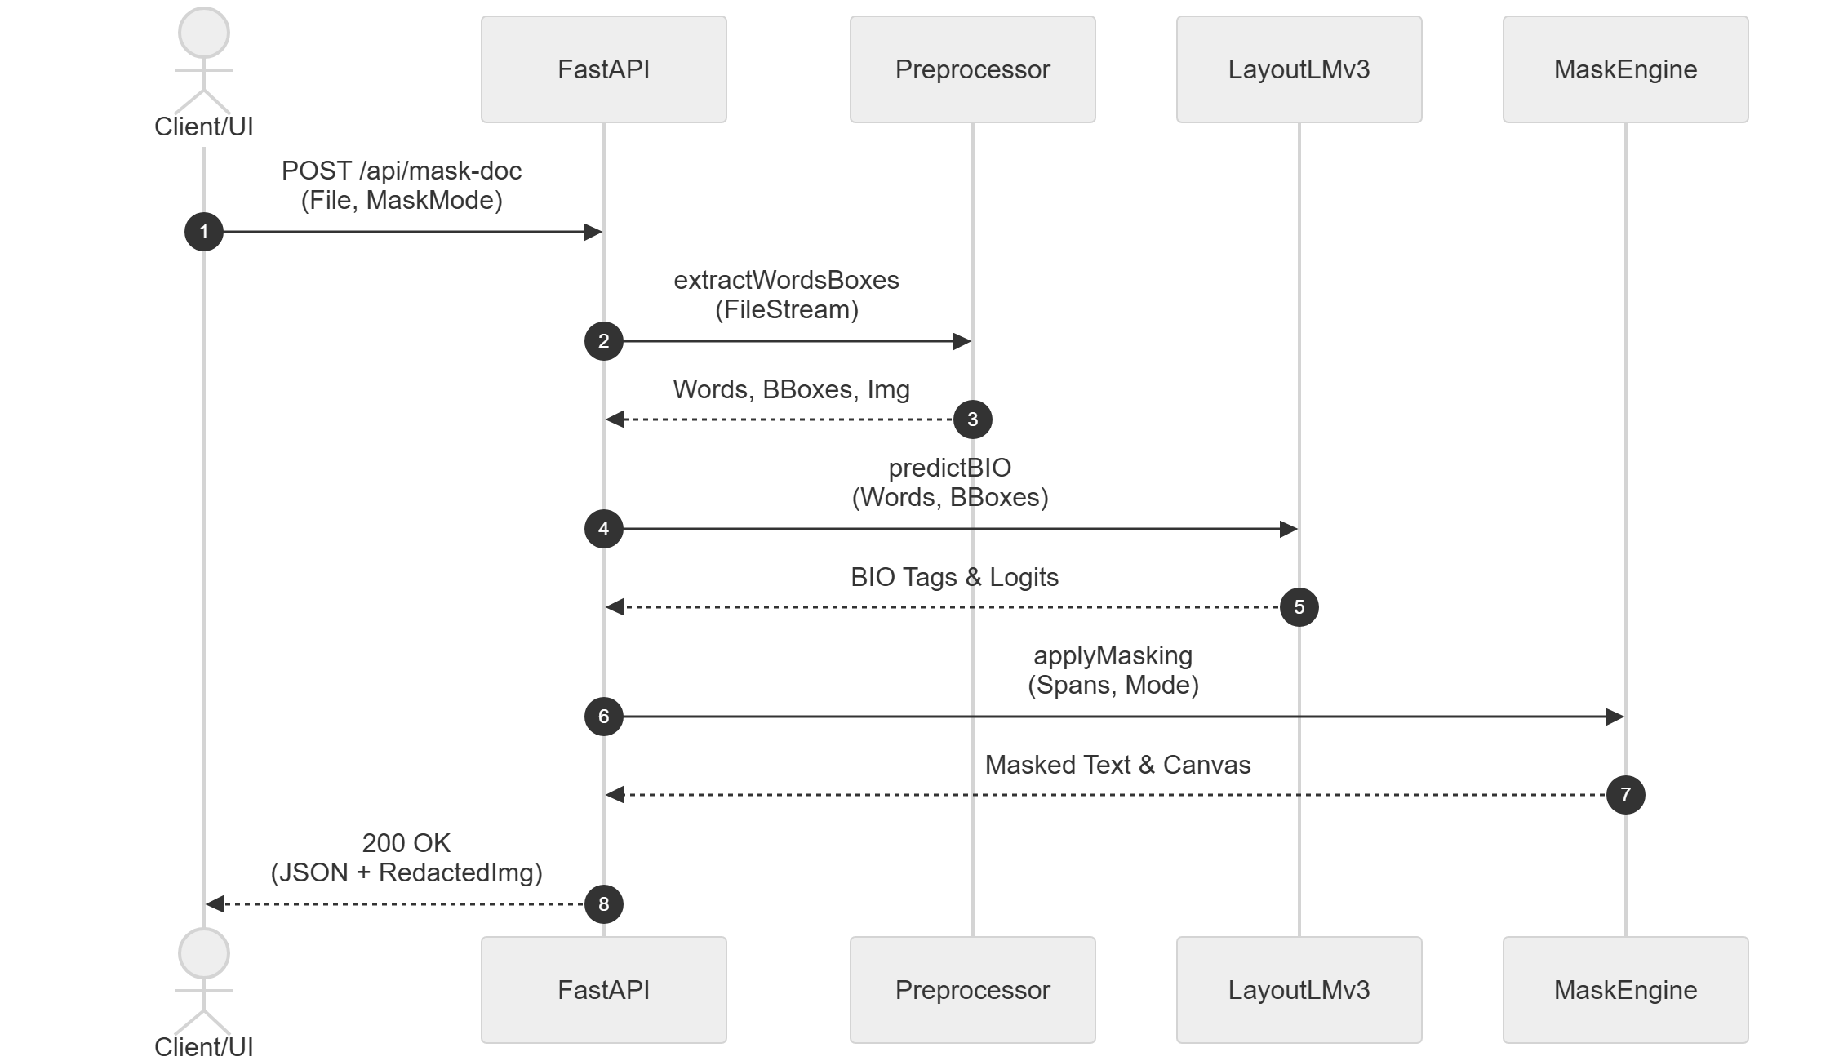
Key Flow:
- Client sends document payload and mask mode to FastAPI router.
- Preprocessor extracts normalized coordinates and word sequences.
- LayoutLMv3 classifies token labels, MaskEngine redacts targets, and API returns output.
Dataflow diagram
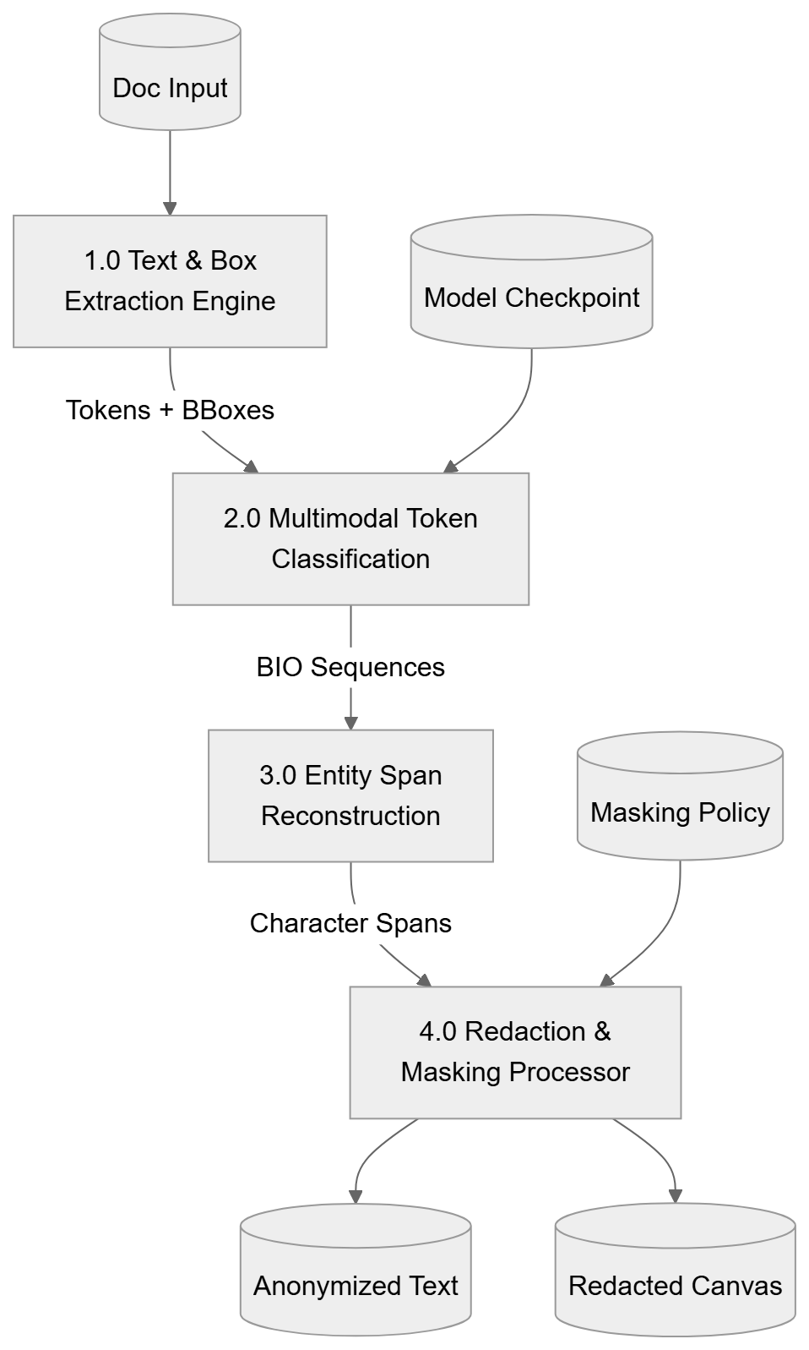
Key Flow:
- Raw inputs are tokenized into 2D spatial coordinate structures.
- Model weights drive BIO sequence classification.
- Entities are reconstructed into absolute spans and redacted according to active policy.

system architecture
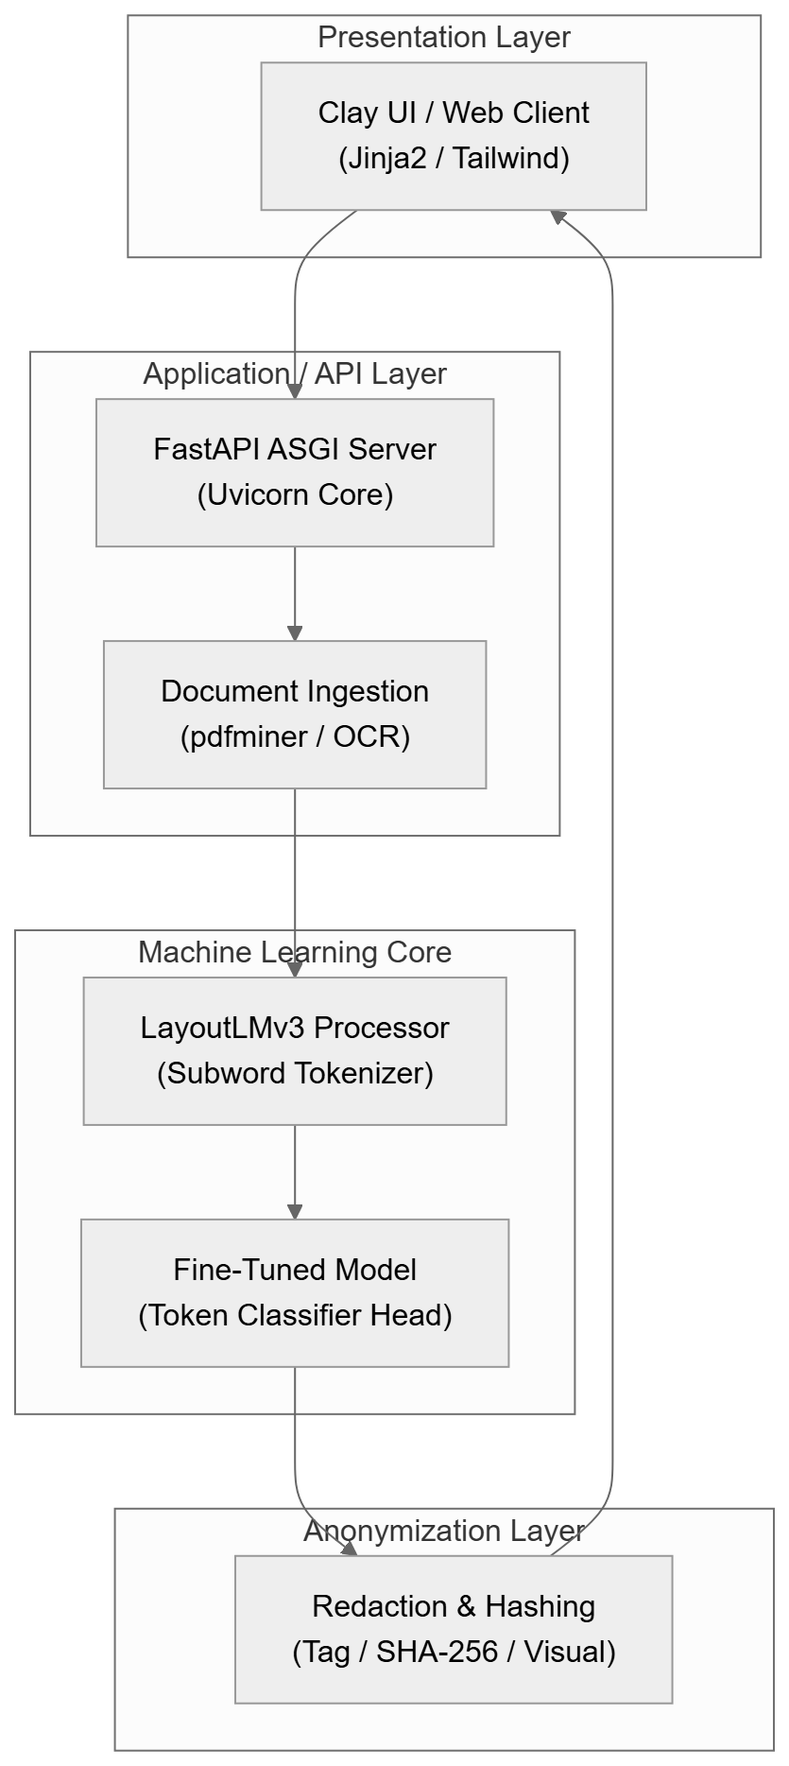
Key Flow:
- Presentation layer interfaces with ASGI service endpoints.
- Document parsers translate inputs into spatial tensor representations.
- Machine learning core performs inference; anonymization layer produces final artifacts.

model architecture
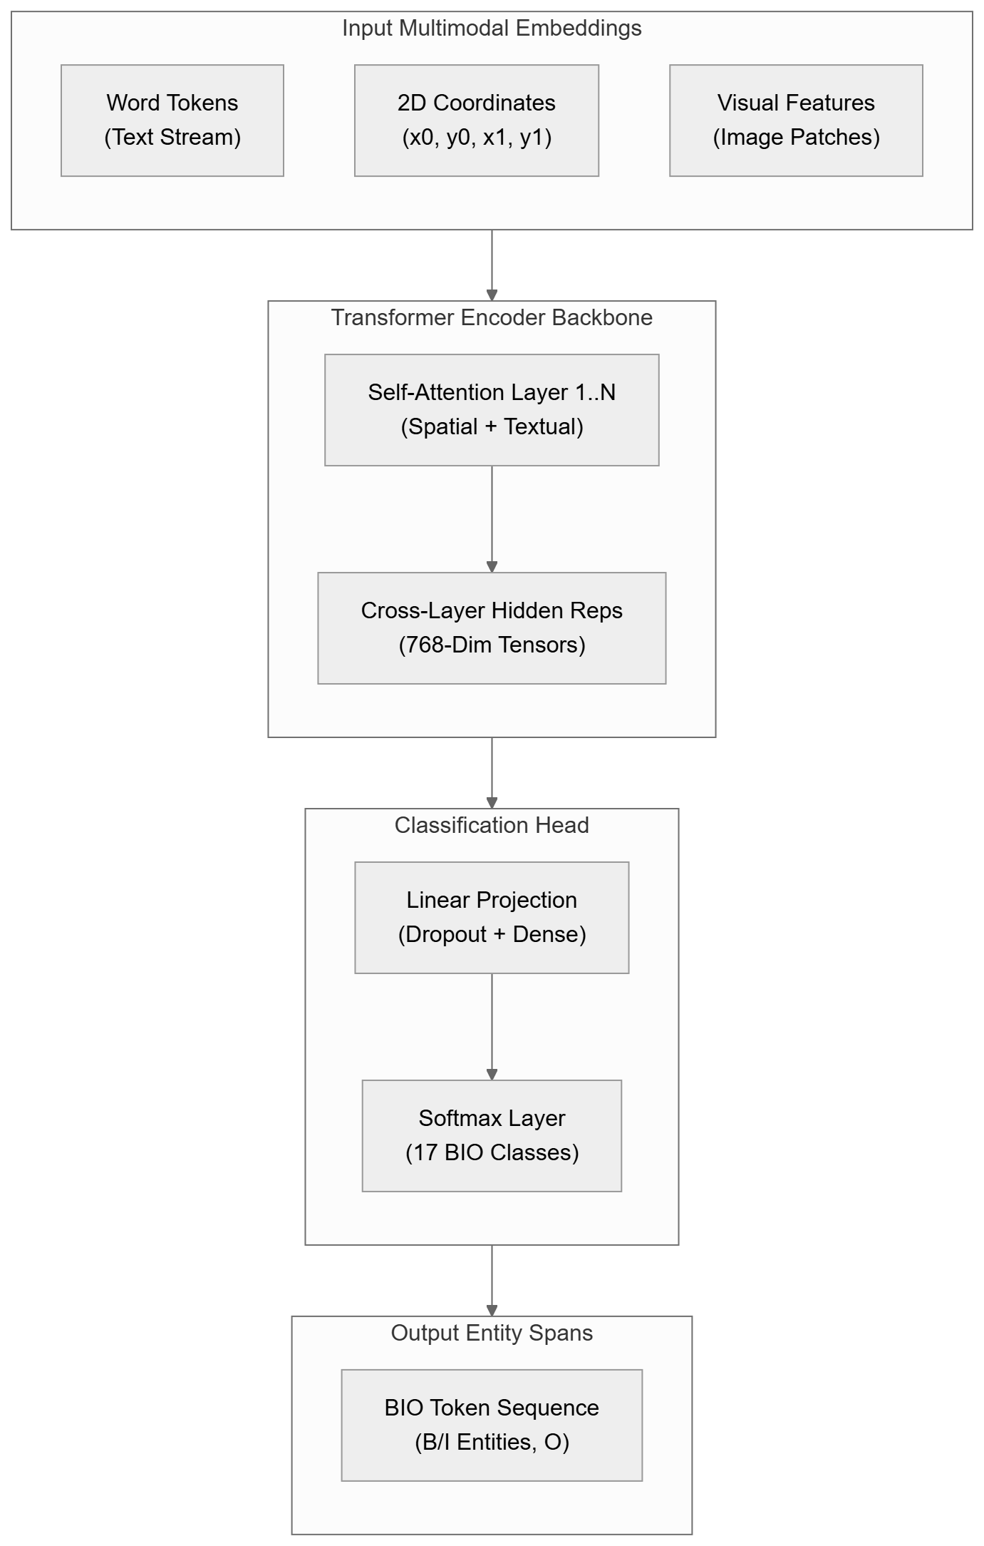
Key Flow:
- Unifies text tokens, 2D coordinates ($0\text{--}1000$ scale), and image features.
- Passes multimodal embeddings through self-attention transformer blocks.
- Linear projection layer maps hidden states to 17-class BIO target probabilities.

